
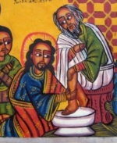
Holy Week Readings and Prayers
Monday
Read Mark 11:12-19
Almighty God, Your Son Jesus Christ cleared the temple of those who desecrated the holy place. Cleanse our hearts from greed and selfishness that we may become the temple of the Living God. Amen

Tuesday

Read Mark 12:28-34

Almighty God, your Son Jesus Christ taught the people the way of righteousness and judgement. Grant us a ready mind and willing spirit to learn from him all that you would teach us. Amen

Wednesday

Read Mark 14:1-11

Almighty God, your Son Jesus Christ withdrew to the quietness of Bethany to prepare for his passion. In the fellowship of his suffering, strengthen us to be more than conquerors in all our trials and temptations. Amen

Thursday

Read Mark 14:32-72

Holy God, source of all love, on the night before he died Jesus gave his disciples a new commandment to love one another. Give us the will to be the servants of others as he was the servant of all. Amen

Friday

Read Mark 15:1-47

O Christ the Master Carpenter who at the last, through wood and nails, purchased our whole salvation, wield well your tools in the workshop of your world, so that we who come rough-hewen to your bench may here be fashioned to a truer beauty of your hand. We ask it for your own names sake. Amen

Saturday

Read Psalm 46

O God, creator of heaven and earth,
As the crucified body of your dear Son was laid in the tomb and rested on this holy Sabbath, so may we wait with him for the coming of the third day and rise with him to newness of life. Amen

Sunday

Read Mark 16:1-20


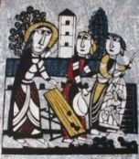
Almighty God, as Christ burst forth from the tomb, may new life burst forth from us and show itself in acts of love and healing to a hurting world. And may that same Christ who lives forever and is the source of our new life, keep our hearts rejoicing and grant us peace this day and always. Amen

